To ensure that the basics are covered in your wall design we have prepared the following wall design checklist. It may also be used by someone checking your work to provide an outline for a consistent review process.

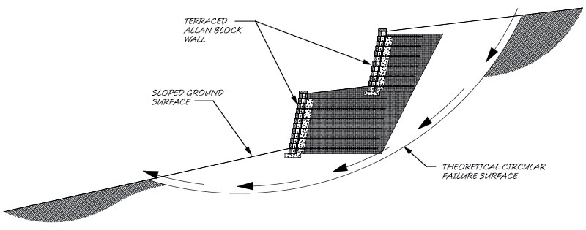
Review Wall Design Plans for Special Conditions:
- Site Drainage Layout
- Global Stability
- Government Regulations
- High Water Table
- Seismic Design Requirements

Review Wall Design Plans For:
- Overall Length of Wall
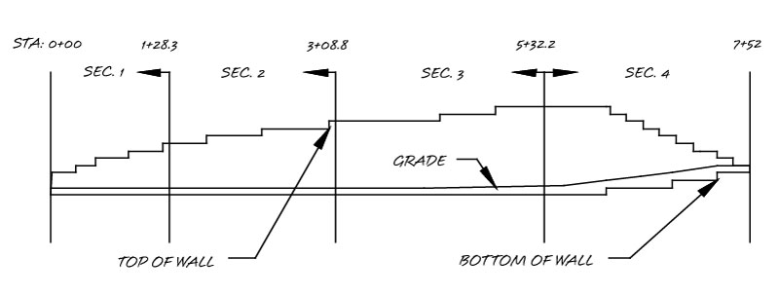
- Station Points
- Plan Layout
- Elevations
- Grades or Slopes Above or Below Walls
- Soil Conditions
  - Retained Soil Friction Angle
  - Infill Soil Friction Angle
  - Foundation Soil Friction Angle
  - Cohesion for Foundation Soil
  - Soil Settlement Potential
- Water Management
  - Above Grade
  - Below Grade
  - Excess Irrigation
- Locations of Catch Basins and Utilities
- Compliance to Specifications
- Surcharges (live, dead, and location)
- Temporary Construction Loads
- Snow or Storage Loads
- Special Provisions

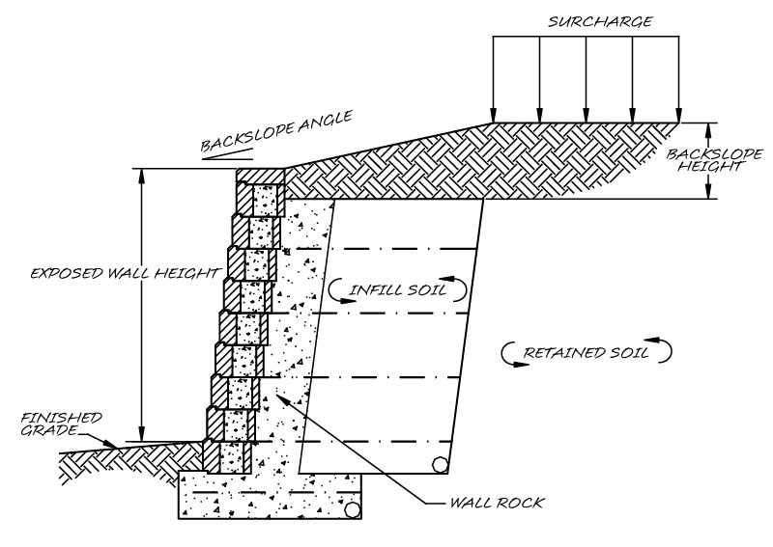
Design Review:
- Grid Length
- Grid Spacing
- Grid Placed on Consistent Courses
- Design Factors of Safety
  - Sliding
  - Overturning
  - Bearing
  - Grid Overstress
  - Pullout from Soil
  - Pullout from Block
  - Internal Compound
  - Global
  - Seismic
- Water Management Details
  - Surface Water Sources
  - Subsurface Water Sources
  - Details for Low Permeability Soils
  - Location and Venting of Toe and Heel Drains
- Overall Quantity Estimates
  - Block
  - Grid
  - Wall Rock
- Construction Details
- General Notes and Specifications

